

Faculty of Computing and Information Sciences
Final Examination Report
Course: DPR400210 – Database Programming with Oracle Database
Project Title: Mobile Repair Shop Management System
Student Name: Osama Aidrous
Student ID: 28264_2024
Instructor: Eric Maniraguha
Academic Year: 2025–2026
Submission Date: 15 July 2026

1. Introduction
The Mobile Repair Shop Management System is an Oracle Database project developed to improve the management of mobile phone repair services. The system stores and manages customer information, technicians, devices, repair requests, spare parts, payments, and audit records. SQL and PL/SQL were used to implement the database, while Power BI was used to create dashboards and reports for data visualization and analysis.
Objectives
To manage customer information efficiently.
To manage technicians and their repair tasks.
To record repair requests and payments.
To manage spare parts used during repairs.
To implement SQL and PL/SQL programming concepts.
To visualize business data using Power BI dashboards.
2. Problem Statement
Many mobile repair shops still use manual methods to record customer information, repair requests, payments, and spare parts. This often leads to data loss, duplicate records, slow service, and difficulties in tracking repair progress. There is a need for a computerized database system that stores and manages all repair shop operations efficiently.
Project Objectives
Design and implement an Oracle Database for a mobile repair shop.
Store customer, technician, device, and repair request information.
Manage payments and spare parts.
Apply SQL and PL/SQL programming concepts.
Implement triggers, packages, procedures, and functions.
Generate reports and dashboards using Power BI.
Improve data accuracy, security, and management efficiency.

3. Methodology
The project was developed using the following methodology:
Problem analysis and requirements gathering.
Database design using Entity Relationship Diagram (ERD).
Database normalization up to Third Normal Form (3NF).
Oracle Database implementation.
Table creation with primary keys, foreign keys, and constraints.
Data insertion using SQL statements.
Development of PL/SQL procedures, functions, packages, and triggers.
Implementation of an audit system and security rules.
Creation of a Power BI dashboard for data visualization and reporting.
Testing and validation of the complete database system.

4. Database Design
The database was designed using an Entity Relationship Diagram (ERD) and normalized up to Third Normal Form (3NF) to eliminate data redundancy and improve data integrity.
Database Tables
CUSTOMERS
DEVICES
TECHNICIANS
REPAIR_REQUESTS
REPAIR_PARTS
SPARE_PARTS
PAYMENTS
PUBLIC_HOLIDAYS
AUDIT_LOG
Relationships
One customer can own multiple devices.
One device can have multiple repair requests.
One technician can handle multiple repair requests.
One repair request can use multiple spare parts.
Each repair request has one payment record.
The audit log stores user activities performed on the database.
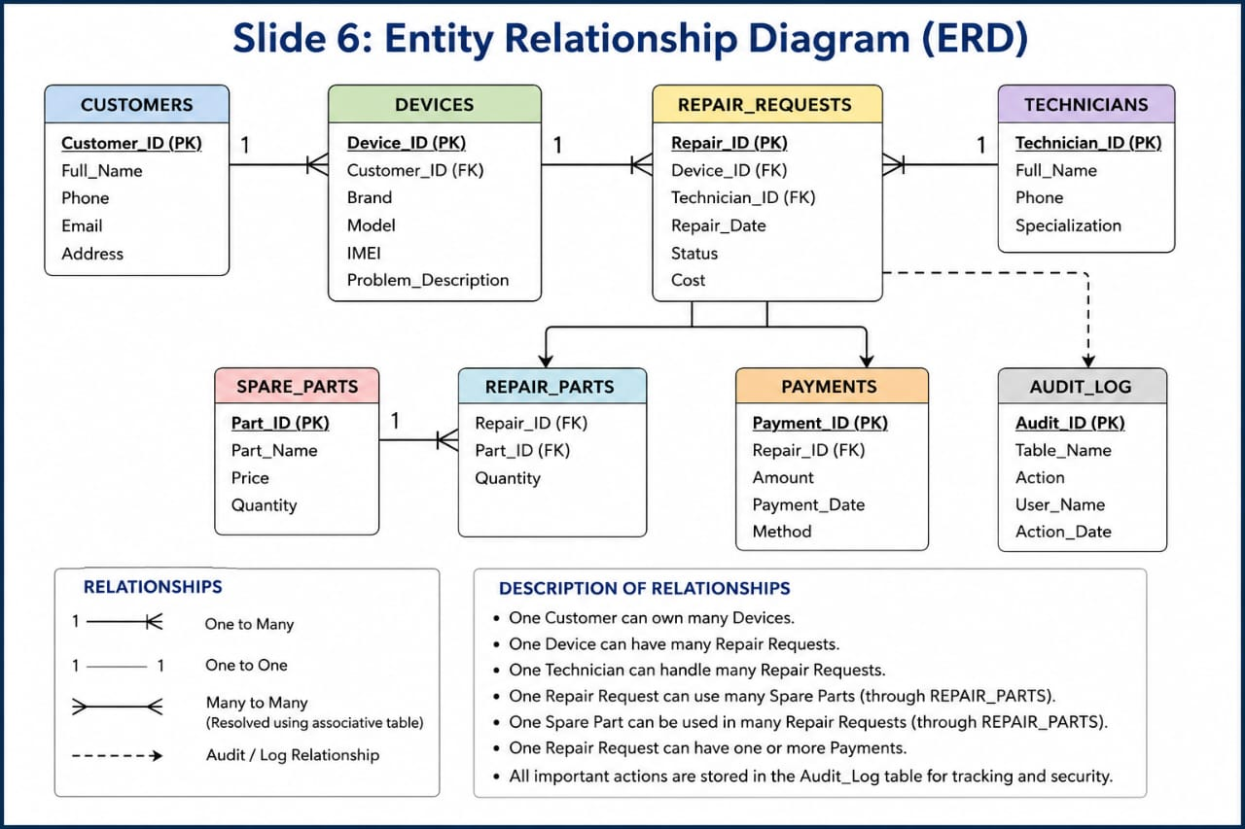

5. Implementation
The implementation of the project was completed using Oracle Database, SQL, and PL/SQL. The database consists of multiple related tables with appropriate primary keys, foreign keys, and integrity constraints.
SQL Implementation
The following SQL operations were implemented:
CREATE TABLE
ALTER TABLE
PRIMARY KEY
FOREIGN KEY
NOT NULL
UNIQUE
INSERT
COMMIT
PL/SQL Implementation
The project includes:
Procedures
Functions
Packages
Triggers
Exception Handling
Business Rules
The system enforces business rules using triggers, including:
Restricting INSERT, UPDATE, and DELETE operations during working days.
Restricting operations on public holidays.
Recording user activities in the AUDIT_LOG table.
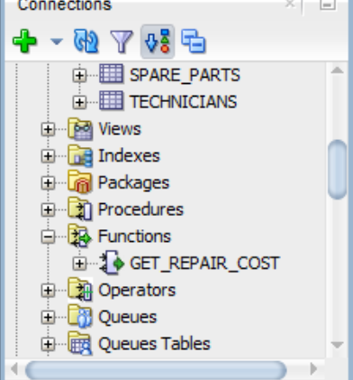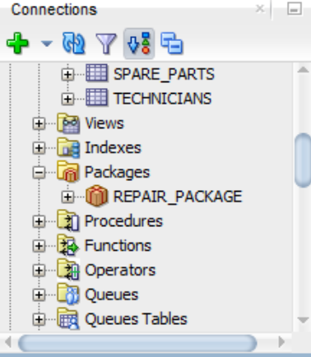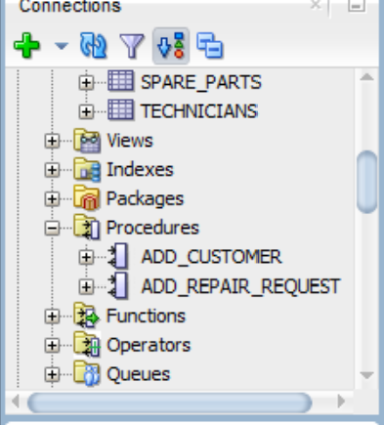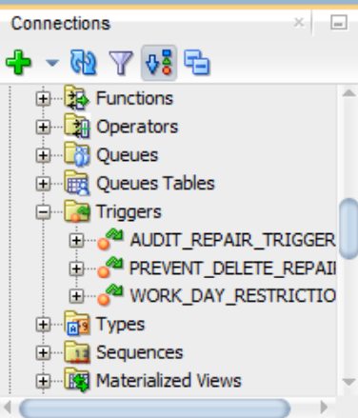

6. Results
The Mobile Repair Shop Management System was successfully implemented using Oracle Database. The system stores and manages customer information, devices, technicians, repair requests, spare parts, payments, and audit records efficiently.
The SQL and PL/SQL programs were tested successfully, including procedures, functions, packages, and triggers. Business rules were enforced through triggers to improve data integrity and security.
A Power BI dashboard was developed to visualize important information such as:
Total Customers
Total Technicians
Payment Methods
Repair Status
Requests per Technician
The dashboard provides a clear overview of the repair shop's performance and supports better decision-making.

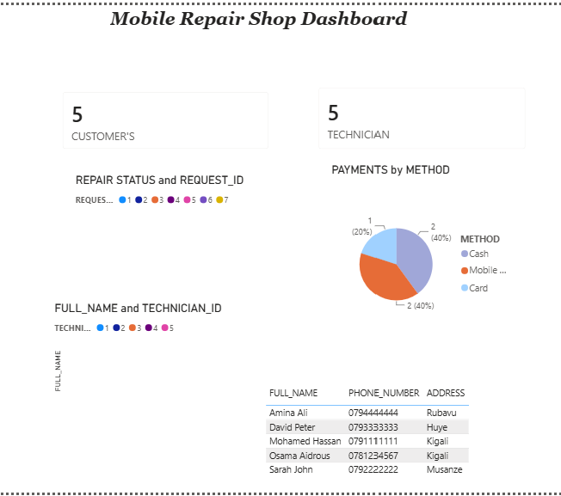

7. Conclusion
The Mobile Repair Shop Management System successfully achieved its objectives by providing an efficient and secure database solution for managing repair shop operations. The system improves data organization, reduces manual work, and ensures data integrity through SQL and PL/SQL features.
The implementation of procedures, functions, packages, triggers, and auditing enhanced the functionality and reliability of the database. In addition, the Power BI dashboard provided meaningful insights through interactive reports and visualizations.
This project demonstrates the practical application of Oracle Database technologies in solving real-world business problems and improving operational efficiency.

References
Oracle Database Documentation.
Oracle SQL Developer Documentation.
Microsoft Power BI Documentation.
Course Materials – DPR400210 Database Programming with Oracle Database.
GitHub Documentation.

